# **Leak Allowance Claims**

## 1.0 Purpose

This document defines the circumstances in which we would be allowed to claim a refund from our water and/or sewerage supplier in the event of a leak on a metered supply pipe, and the process we must follow and information we must provide in order to secure the refund.

## 2.0 Scope

This process applies to all metered water supplies to the University’s UK property portfolio.

## 3.0 Responsibilities

Responsibility for supply pipework up to the property boundary is that of the Water Network Owner (in this region, Thames Water). The property owner/occupier is responsible for all pipework from the boundary into the property (i.e. not just from the location of the meter). See diagrammatic representation below, courtesy of our main water supplier, Castle Water.

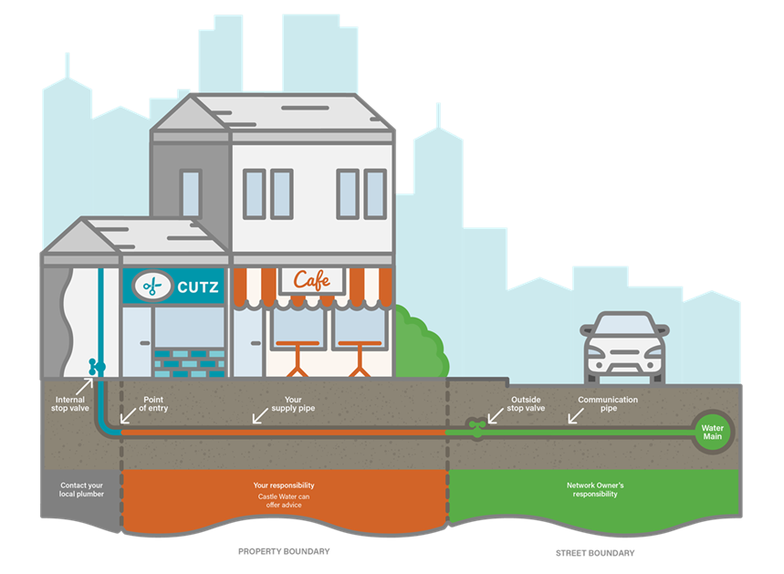

Whilst Castle Water or Thames Water may be able to assist in locating and repairing a leak, if required, it is our responsibility to effect a repair.

## 4.0 Identifying that there is a leak

Evidence of a leak can be visual as in the following situations advised by Thames Water:

* Wet or damp patches in the garden during a dry spell
* Some dirt, or air in the water
* Some cracking in paved areas
* Potholes or sinkholes appearing
* A noticeable reduction in water pressure

Alternatively, this can be identified through a larger than expected bill or via monitoring information available to the Sustainability Team (using the Systemslink monitoring package or the Building Management System).

## 5.0 Financial & Environmental Impacts

Obviously, if there is a leak on a supply pipe, clean water is not being used for its intended purpose. We will be invoiced for all water that passes through the meter. In addition, our invoices also include a charge for handling waste water (the water that returns to the Network Owner’s sewer system) and in most instances the assumption is that an equal amount of water leaves the property and enters the sewer system as was supplied to the property. There are separate charges associated with each of these.

If the leak occurs between the property boundary and the meter then no charges will have been levied on us so no leak allowance can be claimed but we still have a responsibility to effect a repair.

If the leak is after the meter and where it can be proved that the leaked water did not return to the sewer system (normally because it is on an underground pipe or a meter-supply pipe connection), a claim for a refund of that part of the invoice can be made.

Clearly, repairing the leak means we will not be paying both components of the leaking water going forward.

Beside the financial impact, there is a wider environmental impact associated with purifying the supplied water and transporting it to site, so it is sensible to repair leaks as soon as possible.

## 6.0 Leak Repair and Claims Process

The Sustainability Team will submit a claim for a refund to the water supplier. In order to make such a claim, certain information and evidence must be provided. For Maintenance colleagues, the required steps are as follows:

* Once a leak is suspected, **investigate** for evidence of where this is occurring.
* When located, **arrange for a repair** and **advise the Sustainability Team’s Energy Analyst** that there may a leak claim required. In order to make a claim, the repair must have been done within 6 weeks of the leak being confirmed. **Photographic evidence (date stamped if possible) of the leak** needs to be provided to the Network Owner so obtaining this is important.
  + Thames Water state the following on their website:
    - We offer our customers an additional free service: we can arrange a visit to investigate the issue, and help find the leak, and work with you to repair the leak.
  + That likely means that they will help investigate and find the leak free of charge but that we will need to fund the repair. Contact them on **0800 714 614.**
* Obtain **photographic evidence of the repair, date stamped again if possible**.
* **Take a meter reading as soon as possible after the leak is repaired. A date-stamped photograph** of the meter would be helpful in case of any dispute with the Network Owner.
* **Keep the Sustainability Team’s Energy Analyst informed of progress** and provide the photographs and meter readings to them along with a **copy of any contractor’s invoice** for the repair which will be submitted as further evidence that the leak has been repaired.
* The **Energy Analyst will complete the claim form** and submit it to the Water Supply Company.

Version: 1.0

Issue Date: February 2020

Next Review Date: February 2021